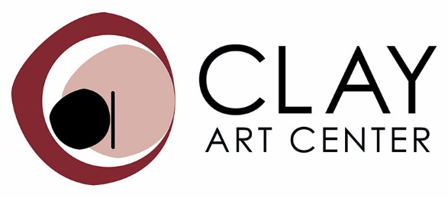

40 Beech Street, Port Chester, NY 10573
www.clayartcenter.org

FOR IMMEDIATE RELEASE:

Media Contact: Regina Farrell-Fagan, Exhibitions and Marketing Director regina@clayartcenter.org, communications@clayartcenter.org
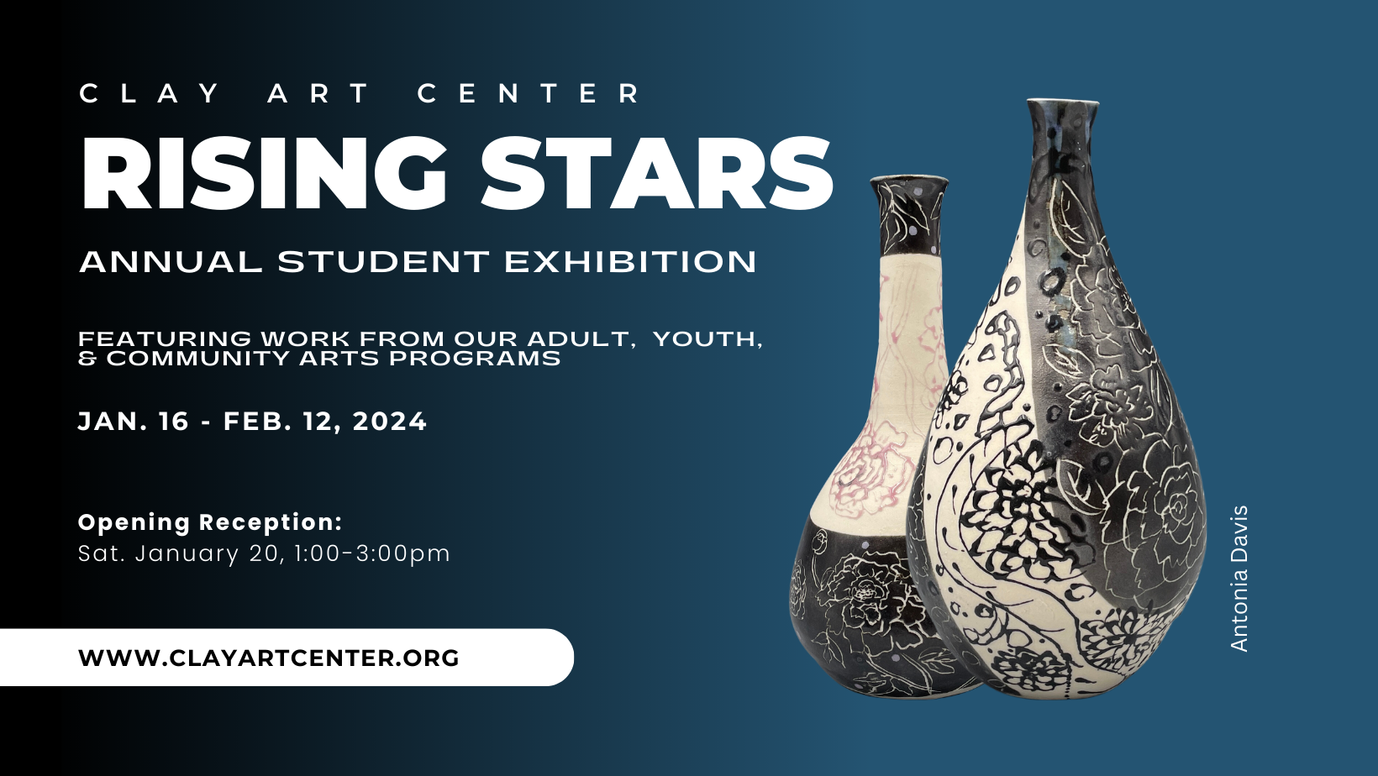
Rising Stars: Annual Student Exhibition at Clay Art Center
January 16th – February 12th, 2024
Clay Art Center is thrilled to present our annual Rising Stars exhibition, a celebration of the accomplishments of our adult, youth, and Community Arts students. This exhibition serves as a platform for artists at various stages of their clay journey to showcase their talent and growth.

Featuring an impressive range of functional and sculptural works, Rising Stars is a testament to the strength and breadth of Clay Art Center's educational programming. The exhibition brings together a diverse group of artists, each contributing their unique perspective and creative voice. This exhibition provides a meaningful opportunity to recognize and acknowledge the technical skills, creativity, and progress of our adult learners, in addition to highlighting the importance of our youth and Community Arts Programs, which play a vital role in fulfilling our mission. By uniting artists from different programs and levels, Rising Stars demonstrates the inclusivity and supportive nature of our artistic community.

Not only does Rising Stars showcase the remarkable achievements of our students, but it also presents the works of our dedicated faculty and teachers. Under their expert guidance, our students flourish and develop their artistic potential.

Additionally, we proudly feature works from our younger students, who bring contagious enthusiasm and joy to their clay creations. Their playful and imaginative pieces serve as a reminder of the pure delight that comes with working in clay.
Join us in applauding the hard work and dedication of our students as they share their passion for clay art in the Rising Stars exhibition. This event serves as a testament to the transformative power of education, the growth of artistic skills, and the invaluable community that Clay Art Center provides.
Please join us for a family-friendly Opening Reception on Saturday, January 20th, 1:00 - 3:00 pm

Learn more

About Our Programs

At Clay Art Center, we provide opportunities for the public to engage with clay and educational clay programming. Our programming caters to individuals of all ages and skill levels.

For those looking to dip their toes in the world of clay, our One-Time classes are perfect. These classes allow both adults and youth to try clay for the first time, providing a welcoming and supportive environment for beginners. Participants can explore their creativity and get a taste of the joy that comes with working with clay.
If you're interested in a more comprehensive learning experience, our Weekly Classes are designed to help students develop their skills over an extended period. Led by experienced instructors, these classes offer a structured curriculum in wheel throwing and handbuilding techniques. Students have the opportunity to dive deeper into their artistic practice and foster their creative growth.

In line with our commitment to community engagement, Clay Art Center also offers Community Arts programming. Through scholarships and grant-funded programs, we ensure that clay art is accessible to everyone who wants to experience working with clay. We partner with local schools, community centers, and nonprofits to provide both onsite and offsite clay programs. By engaging the community with clay art, we aim to promote inclusivity, cultural enrichment, and personal growth.

To sustain our mission and continue providing these valuable opportunities, Clay Art Center relies on the support of grants, donations, and fundraising efforts. By igniting a passion for clay in everybody, we cultivate an appreciation for the arts and foster a vibrant artistic community.
Clay Art Center is a nationally recognized non-profit center for the advancement and practice of ceramic arts offering exhibitions, clay classes for adults and children, studio spaces for clay artists, and outreach programs in the community. It is located in the heart of Port Chester at 40 Beech Street, Port Chester, NY 10573. Join Clay Art Center classes, and exhibitions, and shop online at www.clayartcenter.org.

